GreenT

Mission statement:
We want individuals from around the world to know they will build a future. OneWorld came into existence with mother earth in its mind, we aspire individuals to be aware of their carbon emissions and how they can reduce it and eventually even eliminate it!
https://www.algorand.foundation/news/carbon-neutral

Vision Statement:
Climate change is the number one issue of our generation. Our 5 year goal is for all 50 states to join the GreenT Carbon Market.

What we do:
We’ve created a Carbon Fungible Token named OneWorld, for improving the existing but untrackable cap-and-trade system. Cap and trade is a government regulatory program designed to limit, or cap, the total level of emissions of certain chemicals, particularly carbon dioxide, as a result of industrial activity. Supporters of cap and trade argue that it is a good alternative to a carbon tax. Both measures are attempts to reduce environmental damage without causing undue economic hardship to the industry. Nowadays many companies greenwash their image to appeal customers into believing they’re green-friendly; However, this changes today. Through OneWorld.online, individuals will have the power to quantify how sustainable these companies claim to be. And how exactly would we measure that? Companies as a result of collecting GreenT tokens

companies use cryptocurricies for greent, and its used to

it just represent a metric ton of greenhouse carbon emision, thats why its not non fungible, bc the businesses are elling each this is our differentiator, we’re doing what the government has tried to do but better.

Companies have to, at the end of the year/quarter/fiscal year,

How many companies are in the

https://www.epa.gov/ghgemissions/sources-greenhouse-gas-emissions

Redistribute the wealth from the companies that trash the earth to the companies that take care of it.

Get the current system that exists (cap and market) into the blockchain

Why blockchain

- Anti corrpution
  - Reports show that credits are double counted on closed doors
    - Theres no way to hold govts and companies reliable
      - Solution: blockchain is transparent, it allows consumers to see how many credits these companies are buying and using.
        - This transparency is the best way to achieve carbon neutrality.
        - Consumers will

Algorand
Telos
Cartesi

Business opportunity:
(the problem we are solving, what challenges and pain points will we resolve for our users?)

Why?

We are rapidly approaching the tipping point of climate change, or if the global temperature goes above a certain threshold, the effects of human induced climate change will be irreversible. According to recent studies, if we cut our carbon emissions in half by 2030 we will have a 50% chance of keeping the global temperature under this threshold. In 2005 our average quarterly carbon emissions was 384.04225, and declined to 356.549 in 2020. Applying a linear regression formula, we would expect the average quarterly carbon emissions to decline to 339.365719 by 2030, which would be only a 4.81933% decrease in carbon emissions from 2020 to 2030. To even have a 50% chance of slowing climate change down enough to avoid the tipping point, we need to start reducing our carbon emissions by more than a 10x factor. Thus, we need to be significantly more aggressive method in combatting climate change as a society to save our planet.

Company description:
(what does our company do? What challenges does our company solve?)

Problem:
greenwashing. Companies trash the earth more than ever yet call themselves green and have the reputation of being green-friendly.

Our solution:
We are creating a Carbon Fungible token. All transactions will be stored on blockchain, since it is impossible to hide or erase a transaction on blockchain,

Team:
(Who is involved in this endeavor? Who is on your team and why are you the right person/ people to build this business?)

https://www.algorand.foundation/news/carbon-neutral

Industry analysis:
(Who are your competitors? What are some key factors related to being successful in your industry?)

Competitors:
- existing carbon coins;
  - They are not addressing issues such as:
  - a lack of incentive to reduce carbon emissions
  - high carbon emissions by existing blockchain projects in the space
  - high barrier to entry due to fintech companies understanding the technology, and the average person not understanding it

Nettle labs: They created a carbon credit token utilizing the transparency that blockchain offers by utilizing an Algorand environment to successfully implement blockchain. This also addressed the issue of the high emissions that come from many blockchain projects as Algorand is carbon neutral. Nettle successfully addressing 2 of the 3 biggest barriers to solving this problem makes them our strongest competition. The issue is their business model fails to address the issue of these carbon credits not accurately reflecting how green friendly said company actually is. Nettle fails to do this because of their low transaction costs (1.25% fees for businesses adopting this). 1 nettle token is created for every ton of CO2 emissions removed from the atmosphere, so the idea would be that you can tell which companies are green friendly by looking at how many tokens they have. Due to Nettles low transaction fees, there isnt anything to disincentivize companies from calling themselves green, buying a bunch of tokens and continuing to trash the earth.

Target Market:
(Who are we targeting? Who makes up your target audience? Who are your target segments, buyer personas, and ideal customers?)

We are targeting world governments

Implementation Timeline:
(Briefly, how will you roll out the business? Which phases will be involved?)

Marketing Plan:
(Which channels and platforms will use to reach and convert your target audience? Where will you meet your audience?)

Financial Summary:
What is your cost structure and what are your revenue streams? Describe fixed variable costs and how we will make moneyyyy. Consider sales goals for the near future and long term)

Funding Required:
(What amount of funding will you require from investors? Where will the funding go?)

Climate change is the number one issue of our generation.

Fungible token

Who is going to be in our whitelist?

Reach -mission: “building on web 3 is as easy as on web 2.”
Formal Verification process at compile which makes sure no loss of funds

Klaytn - Layer 1 blockchain platform from SK

Judge:

Junghyun Colin Kim
colin.klaytn@krustuniverse.com

1st - 5k
2nd - 3k
3rd - 2k

Algorand - not gone down once in 3.5 years, green chain. 20th of a penny transaction fee

Carbon negative

1st 5k
2nd 3k
3rd 2k

Telos - layer 1 blockchain
C++, EVM now
10k trans/sec
carbon neutral
MetaMask

6k - defi
4k - real world (bring the world into blockchain)

BNB Chain - layer 1, hasn’t gone down
AvengerDAO - cybersecurity initiative to protect users on BNB Chain

Cartesi - Why: 1. Scaleability 2. Flexibility 3. Programmability
EVM compatible
Can use Python, CPP, JS
Anything can use on linux can use on Cartesi

OpenCV on blockchain

1st 2.5k
2nd 1.5k
3rd 1k

Thegraph - only for advanced Moonbeam hackers
Best use for subgraphs
1st. 3500
2nd 1700
3rd 800

Use existing subgraph for something else
1st 2500
2nd 1000
3rd 500

Brainstorm:

Cartesi - implementing decentralized OpenCV to verify certain logistics have been accomplished (e.g. have you planted a new tree?) gamify it?

Telos - how do we implement blockchain tech into existing organizations?

Carbon reduction for businesses/states create something for states

Carbon credit - Carbon Coins?

Way to verify carbon credits for business?

Potential issue:https://www.climatechangenews.com/2022/08/19/world-bank-launches-carbon-credit-blockchain-registry-to-attract-crypto-investors/
Still incredibly new — IP strategy to capture first to market value?

Combine all coastal cap-and-trade carbon capture states with each other?

The cap = limited amount of crypto so we could limit the amount of pollution emitted

Timeline:
- Group decided to create something related to sustainability and carbon credit;
- Potential issue: https://www.climatechangenews.com/2022/08/19/world-bank-launches-carbon-credit-blockchain-registry-to-attract-crypto-investors/
  - Summary: The World Bank wants to direct the NFT craze towards projects that cut emissions and improve the transparency of carbon offset markets
- https://www.c2es.org/document/us-state-carbon-pricing-policies/#:~:text=Those%20states%20are%20California%20and,Greenhouse%20Gas%20Initiative%20(RGGI).
  - Summary: Compared to command-and-control regulations, carbon pricing is a market-based mechanism that creates financial incentives to reduce greenhouse gas (GHG) emissions. Twelve states that are home to over a quarter of the U.S. population and account for a third of U.S. GDP have active carbon-pricing programs and are successfully reducing emissions. Those states are California and the eleven Northeast states — Connecticut, Delaware, Maine, Maryland, Massachusetts, New Hampshire, New Jersey, New York, Rhode Island, Vermont, and Virginia — that make up the Regional Greenhouse Gas Initiative (RGGI). RGGI is the first mandatory cap-and-trade program in the United States to limit carbon dioxide emissions from the power sector. California’s program was the first multi-sector cap-and-trade program in North America.
  - 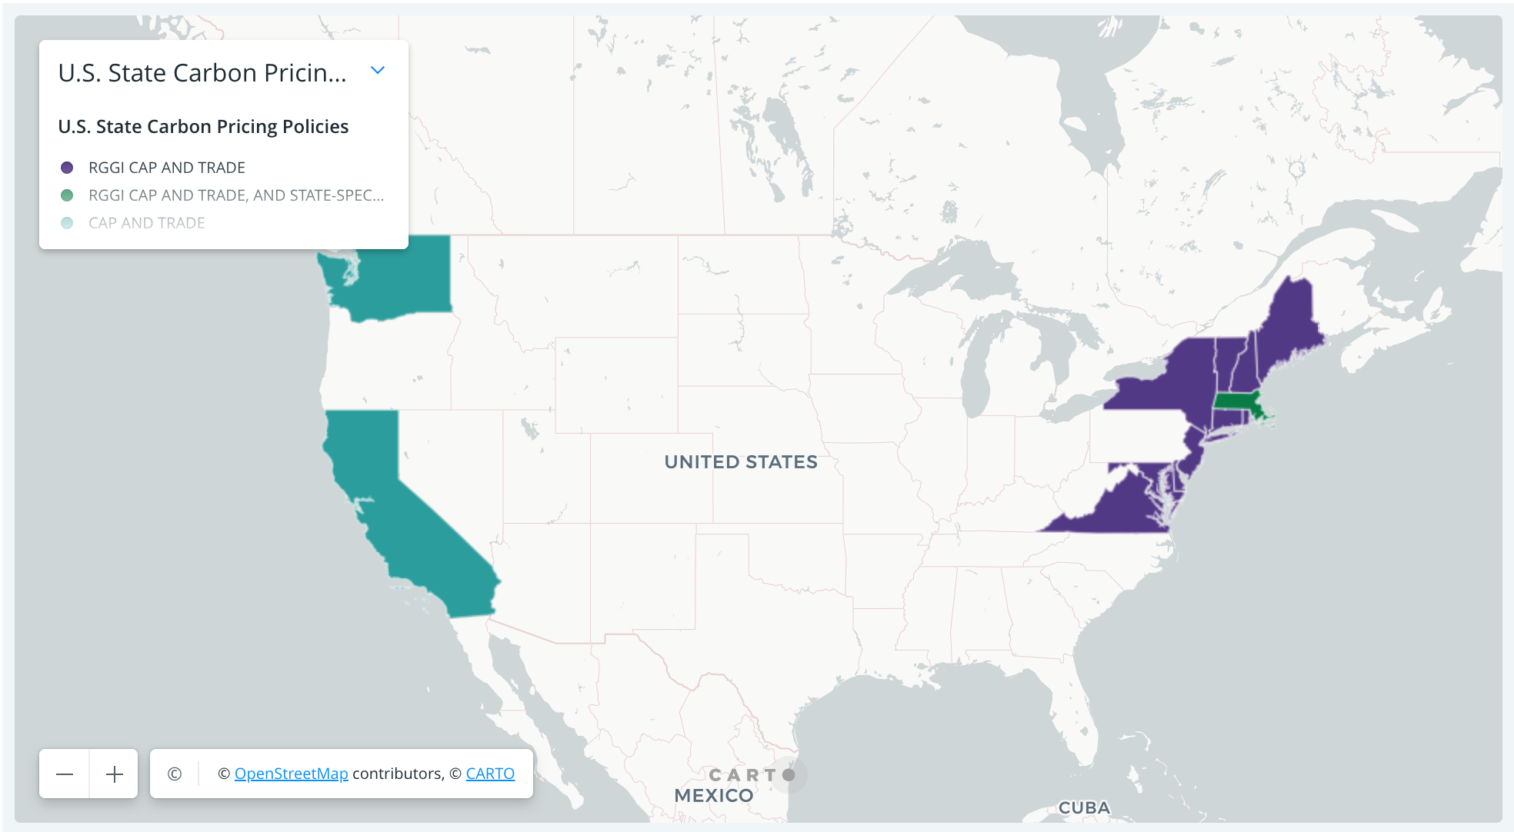

- Still incredibly new — IP strategy to capture first to market value?
- Combine all coastal cap-and-trade carbon capture states with each other?
- The cap = limited amount of crypto so we could limit the amount of pollution emitted.

DAO implementation?

Problems to address:

Lack of transparency due to high barrier to entry:

What do we need to do? Design a carbon credit token (NFT) that is easy to understand for non technical people (reduce barrier to entry):

Blockchain can use lots of energy, this must be addressed to accomplish our goal of reducing carbon emissions.

How will we address this problem?
- Cap and trade: Market Based State Policy, which mimics free economies, 13 states participate, they focus on carbon emissions through the RGGI (Regional Green Gas Intiative).
  - CA & WA are independent.
- The thing that is being traded is a permit for emitting carbon (greenhouse gases),
  - w/o this permit companies are not allowed to emit carbon, this is effective bc govs release only a certain amount of permits, these permits are held as an asset and can be traded.
  - On top of the limited number of permits, these companies are incentivized to reduce or even eliminate their entire emission of greenhouse gasses.

Why Blockchain:
- Transparency
  - NO more Greenwashing; Now there’s no way to verify what they’re saying, and if there’s inquiry about it, it's too complicated/burocratic for the mass public.
  - This is good because with transparency, the younger and more connect generation will take part of policies, government, regular decision-making,
    - Eg. Coke vs Pepsi

Increase In economics, in micro, individuals have complete access to all information regarding organizations, but not a current reality. How can you expect individuals to make informed decision when they don't have the full picture?
  - With blockchain, you can hold the company's reliable!
  - Anti-corruption; can hold both public and private companies accountable for their actions.

thought: Need a way to differentiate selling the coins for profit vs actually using the permits for GH emissions.

Would be a problem if there were an infinite number of permits emitted but this is not the case as there are only xx amounts.

- Our mission is to bring this tech to all states,

- cancel culture (peer pressure them into having the coins),
- tackling the problem of buying/selling coins → charge an absurd amount for just buying and selling
- Incentive for people to get the coins in the first place,

How do we get governments to join us?

- Cancel culture them into accepting it.
- The young generation are worried about their future, with climate change in mind.
- Focus on politicians to vote for this, (with them in mind on how they’re going to get more votes).

Green Coin
Fighting for a better world.

Using Algorand because they are actually carbon negative - they purchase carbon credits. The increase in price of ALGO and the increase of adoption of GreenCoin both feed on each other to protect the planet.

The current system doesn't incentivize companies to actually reduce carbon emissions. Companies buy carbon credits and retire them to offset their emissions but investors also buy them and don’t retire them, in the hope that the price of carbon credits will rise and they can sell them for a profit. Or companies can snap up cheap carbon credits and retire them when the price is high, polluting for cheaper than they would otherwise have done. (Question: is it even clear that governments are accepting this? or is it that participating businesses exchange their carbon credits to whoever buys them?)

How will we address this problem?

Implement carbon credit system, transparency how much carbon credit companies use.

Algorand - developer portal developer.algorand.org/challenges/

dapp

Algorand SDK - beaker - smart contract

Beaker - Phyton framework for building smart contracts on algorand

Challenges:

- Create a basic Algorand Standard Asset
- Deploy a basic smart contract
- Create a basic atomic transacton

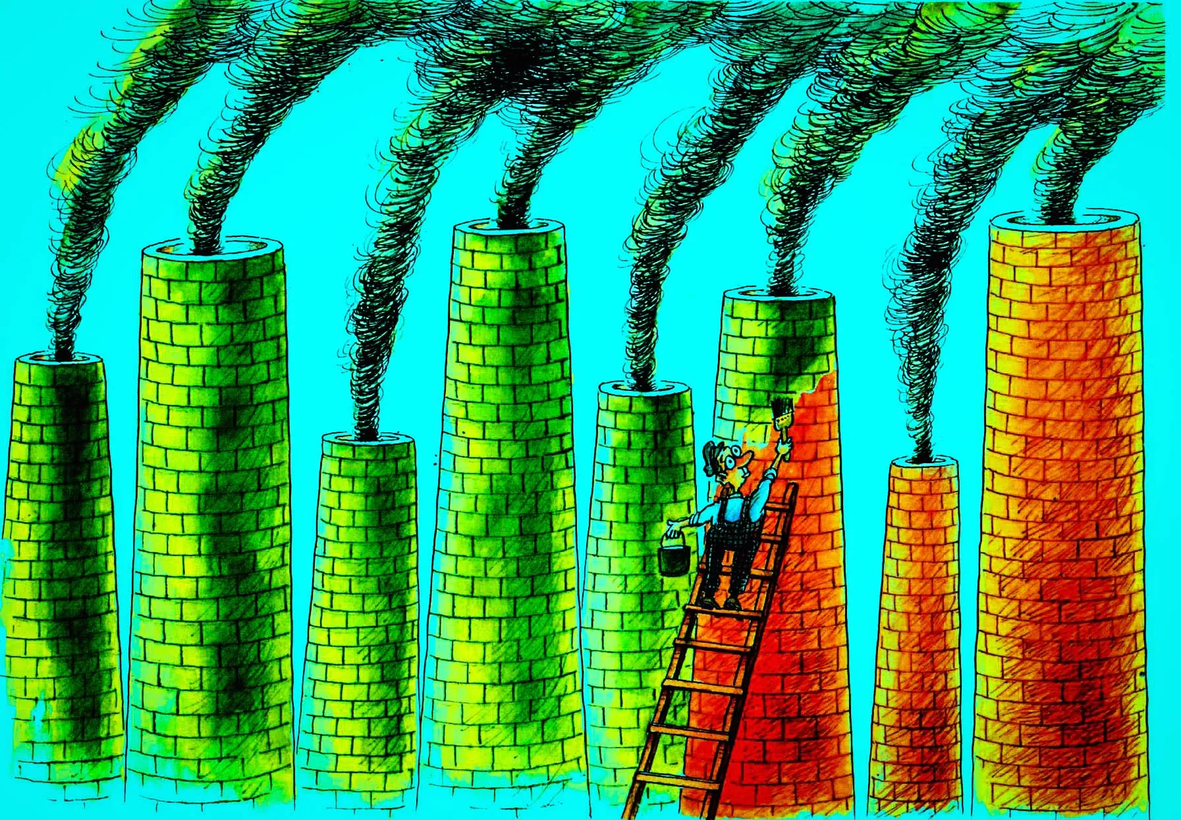

require("@nomicfoundation/hardhat-toolbox");

const privateKey = "0x123...";

/** @type import('hardhat/config').HardhatUserConfig */
module.exports = {
solidity: "0.8.9",
networks: {
goerli: {
url: "https://goerli.prylabs.net",
accounts: [privateKey],
},
baobab: {
url: "https://api.baobab.klaytn.net:8651",
accounts: [privateKey],
}
}
};

https://docs.google.com/presentation/d/1kGKnbxv-KGbWWWiOdfYT5SDhOlpdsN0FFx7Awj1Orm8/edit#slide=id.g157e38d2a41_3_95

